
University of Missouri School of Medicine Free Mobile Sim Training

The Russell D. and Mary B. Shelden Clinical Simulation Center offers programs to improve patient care and safety, explore new research opportunities, and provide lifelong learning experiences to health professionals in all areas of care.

From novice to practicing health care professionals, the SIM builds competency in individuals and teams through experiential learning, assessment and feedback. These patient-centered simulation and simulated participant interactions provide structured practice in a safe environment with a focus on:

- Health, safety and satisfaction of our patients
- Clinical knowledge and decision-making
- Communication skills
- Situational awareness
- Professionalism
- Compassion and respect
- Collaborative teamwork
- Ethical behavior
- High-quality, effective care

Schedule the Mobile SIM in your local community and invite your school health teams and other community partners to attend as a shared professional development opportunity. Email lunddr@health.missouri.edu with questions and to schedule.
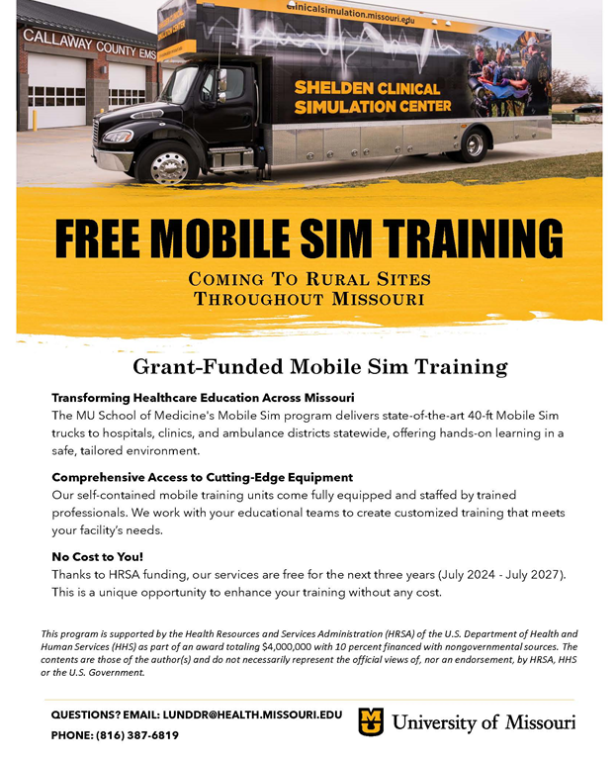

National Drowning Prevention Alliance (NDPA) Launches Expecting and New Parents Water Safety Toolkit
The Water Safety Season Toolkit was updated for the 2026 season. It includes a full campaign schedule compiled of NDPA’s top social posts, video public service announcements, sharable blogs, press release templates, printable documents and so many more resources to help you advocate for water safety and drowning prevention from May through August.
In addition, with a mini grant from the Baby Safety Foundation, the alliance launched the Expecting and New Parents Water Safety Toolkit. For expecting and new parents, water safety starts earlier than many people think. Bath time is often a baby’s first experience with water, making it an important opportunity to begin building safe habits at home and preparing for healthy water acclimation as a child grows. This toolkit was created to help parents and caregivers get started with practical guidance, helpful checklists, and trusted resources designed to support safer bath time routines, increased water safety at home, and spark early conversations about lifelong water safety.


Will there be learning opportunities to learn more about resources and programs we can utilize to address the priority health issue we have selected and developed a five-year work plan to address?

Yes, you should have received calendar invites for our Summer Learning Series in July and August. If not, please reach out to your MCH DNC and she will forward the calendar invites.

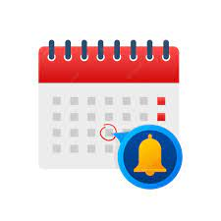
Reminders

- June 2026 (FFY26) Invoicing tool/DA-38 due July 15, 2026

Upcoming Conferences that may be of interest:

- 2026 Missouri Suicide Prevention Conference
July 9, 2026, Wyndham Executive Center, Columbia, MO
Summary - 2026 Missouri Suicide Prevention Conference.

      - School Health Academy 2026, Save the Date
July 21-23, 2026, Sinclair School of Nursing, University of Missouri, Columbia, MO

      - 2026 Missouri Rural Health Conference, Save the Date
September 9-10, 2026, Old Kinderhook, Camdenton, MO
Call to Presenters Annual Conference - MRHA - Missouri Rural Health Association

      - Missouri Highway Safety Conference, Save the Date
September 9-11,2026, Wyndham Executive Center, Columbia, MO

      - 2026 Joint Public Health Conference, Bridging Communities: Connecting Missouri to Better Health, Save the Date
September 15-17, 2026, The Lodge of Four Seasons, Lake Ozark, MO
Calendar of Events – Public Health Association | Missouri

      - 2026 Missouri Behavioral Health Conference, Save the Date
September 16-18, 2026, Hyatt Regency, St. Louis, MO
Missouri Behavioral Health Council | MBHConference

      - citymatch 2026 Conference, Save the Date
September 21-23, 2026, Portland, Oregon
Registration – CityMatCH

      - Maternal Health Action Network (MHAN) 4th Annual Summit, Save the Date
September 25, 2026, Kansas City, MO

      - 9th National Cribs for Kids Conference
Safe Sleep: Rooted in Evidence, Branching into Action
September 29-October 2, 2026, Pittsburgh, PA
https://cribsforkids.org/conference/

      - Missouri WIC Association Conference, Save the Date
October 28-31, 2026, Branson, MO

      - APHA 2026, Save the Date
November 1-4, 2026, San Antonio, TX
APHA Annual Meeting

“Start where you are. Use what you have. Do what you can.
-Arthur Ashe

