Missouri Department of Health and Senior Services
Maternal Child Health (MCH) Services Contract
MCH Priority Health Issue Map


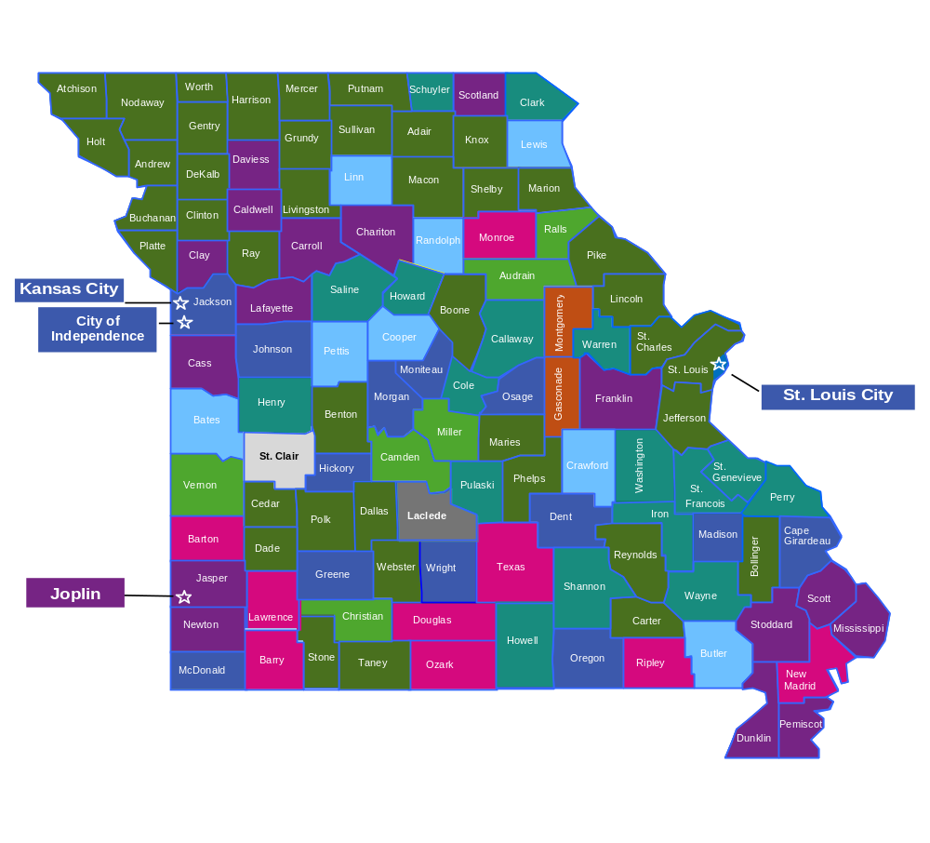
Access to Patient-Centered, Coordinated, and Comprehensive Postpartum Care

Preventive Oral Health Care Services During Pregnancy

Safe Infant Sleep Practices and Environments to Promote Safe Sleep and Reduce Sleep-Related Infant Deaths

Access to Holistic Oral Health Care Services for Children

Access to Family-Centered, Coordinated, Comprehensive, and Community-Based Health Care Services and Supports for Children with and without Special Health Care Needs

A Stable and Supportive Relationship with a Caring Non-Parental Adult to Enhance Adolescent Psychological Well-Being and Empower Youth with the Tools and Training to Reach their Full Potential

Smooth and Successful Transition from Child-Centered to Adult-Oriented Healthcare, Promoting Continuity of Care, Improving Health Outcomes, and Empowering Youth to Manage Their Own Health

Strengths-Based Services and Supports to Promote Healthy Family Relationships and Functioning, Enhance Resilience, Foster Social Connections, and Support Children’s Social and Emotional Development

