
SAVE THE DATE - MCH Services Contract Regional Kick-Off Meetings will be in person this year!

This October, the MCH Services Program will host in-person Contract Regional Kick-Off Meetings. More details will be shared soon, but please save the following dates and locations:
- October 1, 2026 – Grundy County, Trenton, MO
- October 7, 2026 – Madison County, Fredericktown, MO
- October 19, 2026 – Pettis County, Sedalia, MO
- October 22, 2026 – Webster County, Marshfield, MO
All meetings are tentatively scheduled from 10:00 a.m. to 3:00 p.m.
We are so excited to see you all!


Missouri’s Annual Maternal Mortality Report Published
For Immediate Release:
July 8, 2026
Media Contact:
Lisa Cox
Missouri Department of Health and Senior Services
Media Inquiry Form
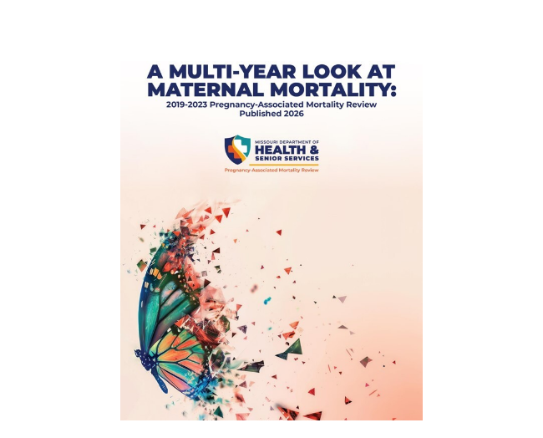
Top causes of pregnancy-related death: cardiovascular disease and mental health conditions
JEFFERSON CITY, MO -- The Missouri Department of Health and Senior Services (DHSS) has published A Multi Year Look at Maternal Mortality in Missouri: 2019-2023 Annual Report on behalf of the state’s Pregnancy-Associated Mortality Review (PAMR) Board, a multidisciplinary board of experts from across the state tasked with examining the causes and contributing factors associated with maternal mortality and ultimately forming recommendations that could prevent these deaths from occurring in the future. The report is an aggregate of five years’ worth of the PAMR Board’s work and is based upon the most recent data available.
The 2019-2023 report contains data, including the timing and leading causes of pregnancy-related deaths, and factors that contributed to these deaths, such as mental health conditions and substance use disorders. The report also reflects the disparities that exist in our state and among our most vulnerable populations, including our Black and publicly insured communities.
Analysis of data and related patient records indicates cardiovascular diseases and mental health conditions (including substance use disorders) were the leading underlying causes of pregnancy-related deaths, followed closely by infections (pneumonia, COVID-19, etc.). An average of 68 Missouri women died while pregnant or within one year of pregnancy each year over 5 years (2019-2023), with the highest number recorded in 2020 (85 deaths).
Other key findings include the following:
From 2019-2023 (340 deaths total):
- The pregnancy-related mortality ratio (PRMR) was 31.2 deaths per 100,000 live births.
- The PRMR for Black women was 2.5 times the ratio of white women, similar to rates in the previous two reports.
- The PAMR Board determined that 79% of pregnancy-related deaths were preventable.
- The PAMR Board determined that all pregnancy-related deaths due to mental health conditions, including substance use disorder (SUD), were preventable.
Finally, the report includes recommendations by the Board for a variety of stakeholders as well as the Board’s major accomplishments to date, some of which are listed below.
- Built Missouri’s maternal health infrastructure, including the state’s first maternal mortality report, the nation’s first maternal mortality dashboard and published Maternal & Neonatal Levels of Care.
- Expanded statewide quality initiatives by establishing the Missouri Perinatal Quality Collaborative (MO PQC), engaging nearly all birthing hospitals, launching clinical safety bundles and publishing progress reports.
- Implemented major maternal health programs, supporting thousands of families through training, care access and targeted interventions.
- Advanced maternal health policy and investment, including $4.3M in state funding, extension of Medicaid postpartum coverage and creation of behavioral health and substance use disorder support centers.
- Strengthened statewide outreach and awareness through largescale PAMR campaigns, provider trainings, public educational efforts and distribution of wellness kits to at-risk pregnant and postpartum women.
Previous years of maternal mortality data is available online through a statewide, interactive dashboard. The 2019-2023 annual report can be viewed at Health.Mo.Gov/data/pamr.
Partner Resources:
Ask Me 5: Ask Me 5 equips both providers and patients to have meaningful conversations that can save lives.
Healthy Moms, Healthy Babies: Its mission is to end preventable maternal and infant health risks by connecting women to quality healthcare and supportive resources that will provide healthy, successful pregnancy and post-partum experiences for both mom and baby.


IN THE SPOTLIGHT

Howell County Health Department

AMCHP’s Evidence-Based Practice Initiative began in 2010 with the establishment of AMCHP’s Innovation Station Database, now called the MCH Innovations Database. This database was developed to serve as a repository of effective MCH practices that Title V professionals could look to for inspiration and could replicate or adapt to their own context. Over time, this resource has evolved to serve the entire MCH community, beyond Title V. More than just a database, AMCHP’s Innovation Hub has grown to be a comprehensive online platform of resources to help MCH professionals identify, implement, share, and replicate practices and policies grounded in evidence.
The MCH Innovations Database is a searchable repository of “what’s working” in the field that improves the health and well-being of MCH populations. It features both practices and policies happening across the country that positively benefit women, children, families, and communities. Practices in the database are assessed along a continuum and receive a designation of Cutting-Edge, Emerging, Promising, or Best depending on their work’s demonstrated impact, among other criteria. Policies in the database are assessed according to whether or not they meet the criteria to be considered a model example of Evidence-Informed Policy Development, Policy Implementation, or Policy Evaluation.

Howell County Health Department was recognized as a Cutting-Edge Practice in AMCHP’s Innovation Station Database. Check out their spotlighted work here:
Howell County Women's Health Services Program - AMCHP
Cutting-Edge-Howell-County.pdf

Please continue sharing your good works with us!



When will the FFY2027–2031 work plan be available in the new progress report Format?

Many of you have asked when the updated progress report template that reflects the FFY2027–2031 work plan will be released. Your MCH District Nurse Consultant (DNC) will send out the progress report on October 1.

We appreciate your patience as we prepare everything for the
upcoming transition.


Reminders

- August 2026 (FFY2026) Invoicing tool/DA-38 due September 15, 2026
- FFY2026 End of Year Reporting, to include Contract Outcomes report due October 31, 2026
- Additional Reminder: Please take a moment to review your remaining funding for the current fiscal year. FFY2026 ends September 30, 2026. If you have any questions or if anything appears uncertain, reach out to DNC for clarification.

Upcoming educational opportunities that may be of interest:

- MCH Summer Learning Series Dates:

August 19th
Bryce Starr, UMKC, Institute for Human Development
Missouri Maternal Health Action Network

August 26th
Kyleigh Brown, MU Extension
Building Strong Families Program

September 2nd
Benjamen Pringer, Program Manager, Adolescent/School Health Program, MO DHSS
Teen Outreach Program, Making Proud Choices, Adolescent Health Initiatives

      - 2026 Missouri Rural Health Conference, Register Here
September 9-10, 2026, Old Kinderhook, Camdenton, MO

      - Missouri Highway Safety Conference, Register Here
September 9-11,2026, Wyndham Executive Center, Columbia, MO

      - 2026 Joint Public Health Conference, Bridging Communities: Connecting Missouri to Better Health, Register Here
September 15-17, 2026, The Lodge of Four Seasons, Lake Ozark, MO

      - 2026 Missouri Behavioral Health Conference, Register Here
September 16-18, 2026, Hyatt Regency, St. Louis, MO

      - citymatch 2026 Conference, Register Here
September 21-23, 2026, Portland, Oregon

      - Maternal Health Action Network (MHAN) 4th Annual Summit, Register Here
September 25, 2026, Kansas City, MO

      - 9th National Cribs for Kids Conference
Safe Sleep: Rooted in Evidence, Branching into Action
September 29-October 2, 2026, Pittsburgh, PA
https://cribsforkids.org/conference/

      - Missouri WIC Association Conference, Save the Date
October 28-31, 2026, Branson, MO

      - APHA 2026, Save the Date
November 1-4, 2026, San Antonio, TX
APHA Annual Meeting

      - The Missouri Connected Care & Ethics Summit
November 19 & 20, Columbia, MO
2026 Missouri Connected Care and Ethics Summit

“When summer opens, I see how fast it matures and fear it will be short; but after the heats of July and August, I am reconciled, like one who has had his swing, to the cool of autumn.”

-Ralph Waldo Emerson

