
The NEW Health.Mo.Gov is Here!
We are excited to share with you how the Missouri Department of Health and Senior Services (DHSS) is creating a better user experience for Missourians. The new site offers clearer navigation, improved accessibility and a more user-friendly experience. We hope these enhancements make it easier for you and those you serve to find the information you need.
Learn more about our improvements in the attached deck.
DHSS has a few requests for you during this transition:
- Please take a moment to visit the new site and familiarize yourself with the updated layout.
- If you share links in your own communications or materials, consider reviewing and updating them to ensure they point to the correct pages.
- If you encounter any issues—such as broken links—please let us know. Your feedback is valuable and helps us continue improving.


Lead Poisoning Essentials: Critical Knowledge for Clinicians Masterclass
Did you know that Missouri is the nation’s top producer of primary lead ore and that approximately 65 percent of our state’s housing was built before 1978? For these reasons and many more, lead poisoning awareness is something often overlooked but is essential knowledge for health care practitioners.
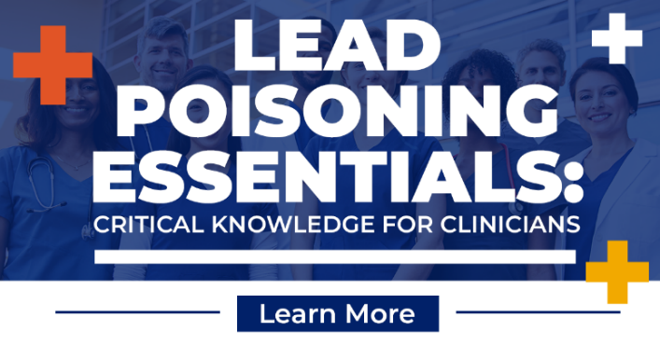
The Childhood Lead Poisoning Prevention Program (CLPPP) is offering a free course for clinicians interested in learning more about lead and lead poisoning, while also seeking educational credit. Participants who complete this Lead Masterclass course will gain a deeper understanding of Missouri-specific lead testing requirements and blood level management protocols; evaluate the signs, symptoms, and risk factors of childhood lead poisoning; and implement evidence-based strategies related to elevated blood lead levels.
Enroll for free at Lead Poisoning Essentials: Critical Knowledge for Clinicians and earn 1.5 continuing education credits through the Accreditation Council for Continuing Medical Education (ACCME). This six-module course will provide stopping points to accommodate your busy schedule.
For more information on Lead Poisoning Prevention, visit Lead Poisoning Prevention or call 573-751-6102.

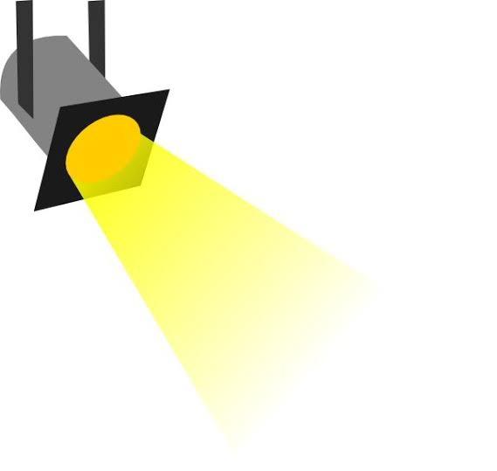
IN THE SPOTLIGHT
The Cooper County Public Health Center recently received the National Association of County and City Health Officials (NACCHO) Promising Practice Award for its School-Based Tobacco, Vape, and Substance Use Prevention Initiative.

Developed in response to priorities identified through the Cooper County Community Health Assessment and Community Health Improvement Plan, the initiative provided evidence-based prevention education to students across Cooper County through partnerships with local schools and Compass Health Network.

The initiative implemented two evidence-based school-based prevention programs: Catch My Breath and Too Good for Drugs. The project was coordinated by Reshma Fatima, MPH, Health Educator and Lead for the Tobacco, Vape and Substance Use Prevention Action Teams, who led program planning, implementation, partnership development, and evaluation activities
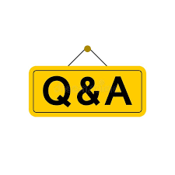

Are any reports due at the end of the current contract year?

Yes.

You can expect to receive an email on October 1st from Sara Gorman, MCH Services Program Manager, with reporting requirements and guidance for completion. These end of year reports will be due to your MCH District Nurse Consultant on October 31, 2026.

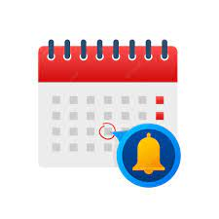

Reminders

- September 2026 (FFY2026) Invoicing tool and request for payment form due to the MCH Services Program on October 15, 2026. This will be the last invoice for the FFY2026 contract year.

Upcoming Learning and Networking Opportunities

- MCH Services Contract Regional Kick-Off Meetings

October 1
Grundy County Health Department Annex
1307 East 17th St.
Trenton, MO 64683

October 7
Madison County Health Department
105 Armory St.
Fredericktown, MO 63645

October 19
State Fair Community College Thompson Conference Room
3201 W 16th St.
Sedalia, MO 65301

October 22
Webster County Health Unit
Location TBD
Marshfield, MO 65706

- Missouri WIC Association Conference, Save the Date
October 28-31, 2026, Branson, MO
Events - Missouri WIC Association

- APHA 2026, Register Now
November 1-4, 2026, San Antonio, TX
Registration Information

- 2026 MOAAP Caring for Kids Conference, Register Now
November 6, 2026, Columbia, MO
2026 MOAAP Caring for Kids Conference & CME

- 2026 Missouri Coalition for Children Fall Conference, Save the Date
November 17-19, 2026, Lake Ozark, MO
MCC Conference and Training - Missouri Coalition for Children

      - The Missouri Connected Care & Ethics Summit, Register Now
November 19-20, 2026, Columbia, MO
2026 Missouri Connected Care and Ethics Summit

      - Governmental Public Health Summit 2026, Register Now
December 7-9, 2026, Lake Ozark, MO
Governmental Public Health Summit 2026

      - Missouri Coordinated School Health 34th Annual Conference, Save the Date
February 24-26, 2027, Lake Ozark, MO
Missouri Coordinated School Health Coalition (MCSHC) -

      - AMCHP 2027, Save the Date
March 6-9, 2027, Washington D.C.
AMCHP Conference - AMCHP

      - MO HealthNet Division invites you: Optimizing Benefits for Maternal & Infant
Health Meetings, Register Now, https://www.surveymonkey.com/r/CPSSQHG
October 8, 2026
St. Louis 9am – 3pm
Lunch Provided
SSM Health, St. Mary’s Hospital
6420 Clayton Road, Kohler Auditorium
2nd floor, St. Louis, MO 63117

November 3, 2026
Liberty 9am – 3pm
Clay County Health Department
800 Haines, Liberty, MO 64048

December 3, 2026
Nixa 9am – 3pm
CC Links
1548 N Commercial Road
Nixa, MO 65714

December 10, 2026
Springfield 9:30am – 3:30pm
The Library Center: Annie Busch Auditorium
4653 S Campbell Ave
Springfield, MO 65810

January 12, 2027
Cape Girardeau 9:30am – 3:30pm
Cape Girardeau Public Library
Oscar Christian Hirsh Community Room
711 Clark St, Cape Girardeau, MO 63701

“A life is not important except in the impact it has on other lives.”

-Jackie Robinson

