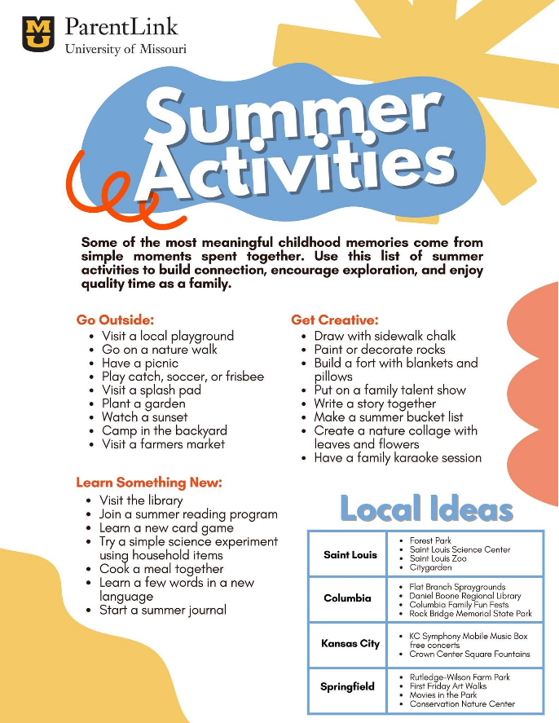

ParentLink is on Social Media

Find ParentLink on Facebook and Instagram and give them a FOLLOW.

Share content and photos directly to your LPHAs social
media platforms, such as the Summer Activities list.


Missouri Department of Social Services has published the ToRCH Care Hub Onboarding and Operations Procedures Manual
The Missouri Department of Social Services (DSS) has published the ToRCH Care Hub Onboarding & Operations Procedures Manual to support organizations participating in Missouri’s Rural Health Transformation Program (RHTP).
The Hub Manual serves as the primary operational guide for ToRCH Care Hubs. It outlines the end-to-end process for Hub onboarding, governance and leadership structures, operating and support models, roles and responsibilities, localized programs, standard operating procedures, and data and assessment tools. It also includes key templates, tools, and sample materials to support Hub planning and ongoing operations.
The Manual is designed to support Hub Anchors and members, Regional Care Networks (RCNs), and other partners and stakeholders involved in establishing and operating ToRCH Care.
DSS encourages all interested hub participants to read and review the Manual alongside other RHTP program materials. DSS has also prepared a Frequently Asked Questions (FAQs) document to assist. These are working documents.
By establishing a shared understanding of ToRCH Care expectations, processes, and operational requirements, the Manual aims to be a comprehensive and continuously updated resource for all ToRCH Care Hubs.

Links:
- ToRCH Care Hub Onboarding & Operations Procedures Manual
- ToRCH Care FAQs

Questions may be directed to DSS.RHTP@dss.mo.gov


IN THE SPOTLIGHT

Clay County Public Health Center

MOCPHE: Innovative Leadership

Clay County Public Health Center received the Innovative Leadership Award for creating a community-centered, highly replicable model of public health outreach through their annual Family Fun Day. What began as a small gathering has grown into a major countywide event, engaging more than 30 partners and drawing over 2,200 residents in 2025, all while delivering practical education on nutrition, safety, physical activity, mental wellness, literacy, and local resources. Their team’s intentional design, from diverse educational stations to thoughtful additions like a Lactation Lounge, demonstrates how public health can meet families where they are and build lasting trust. This event exemplifies an innovative, high-quality program that other LPHAs can easily adapt to strengthen relationships and improve community health.

NACCHO: Promising Practice

“Better Health, Behavior, and BMX Bikes: A Community Marketing Model That Moves Families”, was selected as a Promising Practice by the National Association of County and City Health Officials (NACCHO). The program reflects the strength of the positive impact local health departments have on communities and will be featured in the Model Practices Database for other local health departments to review and replicate.

Please continue sharing your good works with us!


Can we attend all Summer Series dates or just the priority health issue we have selected to address?

We encourage you to attend any and all of the Summer Series dates that are of interest to you. Please see the schedule below:

July 15th

Kaitlyn Thomas, Director, Maternal Special Projects, Missouri Hospital Association
Perinatal Quality Collaborative, Maternal-Child Learning and Action Network, Ask Me 5

July 22nd

Lisa Schlientz, MPH, IBCLC, State Breastfeeding Coordinator MO DHSS
Christine Schrader, Nutritionist, IBCLC, MO DHSS
Missouri Breastfeeding Coalition, Missouri Supports Breastfeeding

July 29th

Gwen Sullentrup, Chief, Office of Dental Health, MO DHSS
Office of Dental Health Programs and Resources

August 5th

Bradd Anderson, Director, ParentLink, MU College of Education/Human Development
ParentLink Resources, Parenting Corners, Court-Approved Parenting Classes

August 12th

Eric Hueste, Chief, Office of Emergency Coordination
Ready in 3, Community-Based Emergency Preparedness

August 19th

Bryce Starr, UMKC, Institute for Human Development
Missouri Maternal Health Action Network

August 26th

Kyleigh Brown, MU Extension
Building Strong Families Program

September 2nd

Benjamen Pringer, Program Manager, Adolescent/School Health Program, MO DHSS
Teen Outreach Program, Making Proud Choices, Adolescent Health Initiatives

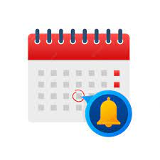
Reminders

- July 2026 (FFY26) Invoicing tool/DA-38 due August 15, 2026

Upcoming Conferences that may be of interest:

      - 2026 Missouri Rural Health Conference, Save the Date
September 9-10, 2026, Old Kinderhook, Camdenton, MO
Call to Presenters Annual Conference - MRHA - Missouri Rural Health Association

      - Missouri Highway Safety Conference, Register Here
September 9-11,2026, Wyndham Executive Center, Columbia, MO

      - 2026 Joint Public Health Conference, Bridging Communities: Connecting Missouri to Better Health, Save the Date
September 15-17, 2026, The Lodge of Four Seasons, Lake Ozark, MO
Calendar of Events – Public Health Association | Missouri

      - 2026 Missouri Behavioral Health Conference, Save the Date
September 16-18, 2026, Hyatt Regency, St. Louis, MO
Missouri Behavioral Health Council | MBHConference

      - citymatch 2026 Conference, Save the Date
September 21-23, 2026, Portland, Oregon
Registration – CityMatCH

      - Maternal Health Action Network (MHAN) 4th Annual Summit, Save the Date
September 25, 2026, Kansas City, MO

      - 9th National Cribs for Kids Conference
Safe Sleep: Rooted in Evidence, Branching into Action
September 29-October 2, 2026, Pittsburgh, PA
https://cribsforkids.org/conference/

      - Missouri WIC Association Conference, Save the Date
October 28-31, 2026, Branson, MO

      - APHA 2026, Save the Date
November 1-4, 2026, San Antonio, TX
APHA Annual Meeting

      - The Missouri Connected Care & Ethics Summit
November 19 & 20, Columbia, MO
2026 Missouri Connected Care and Ethics Summit

“An ounce of prevention is worth a pound of cure.”

-Benjamin Franklin

