Missouri Department of Health and Senior Services
Maternal Child Health (MCH) Services Program
District Nurse Consultant (DNC) Map

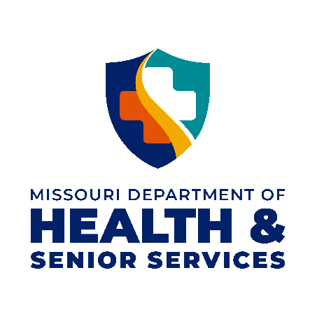
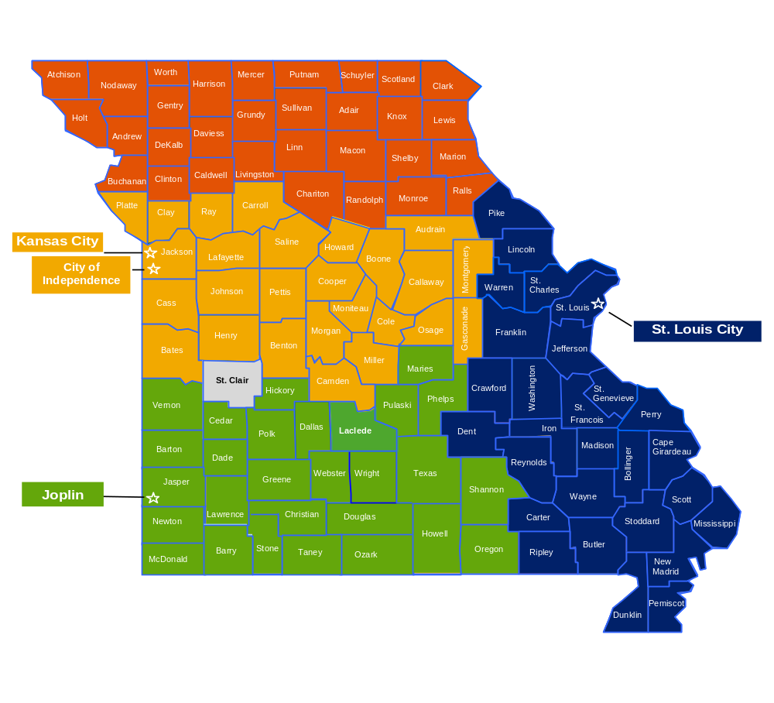
Sara Gorman, MSN, RN
Program Manager

Ph: 573.522.2731
E: Sara.Gorman@health.mo.gov
Sara Thompson, BSN, RN
Northern District

Ph: 660.385.0796
E: Sara.Thompson@health.mo.gov
Macey Shinn, MPH, BSN, RN, CHES®
West Central District

Ph: 573.526.4988
E: Macey.Shinn@health.mo.gov®
Lindsey Cobb, MSN, RN
Southwest District

Ph: 417.895.6964
E: Lindsey.Cobb@health.mo.gov
Amy Bradshaw, BSN, RN
East/Southeast District

Ph: 573.290.5186
E: Amy.Bradshaw@health.mo.gov

Rev: 05/18/2024

